***NecroNursery World Bible***

Necromancy has long existed in the world, dating back to the ancient days of the Greeks. While the relevance of necromancy hasn’t shown its head in the world for a long time, it lurks in the shadows. You are an apprentice necromancer in a hidden society of necromancers. While you might expect to raise the dead, necromancers have used science to their advantage and now grow undead from readily available seeds. Grow undead, raise them from seed to maturity, and try not to make them so dead that even your teacher can’t bring them back.

***The Mentor***

Your teacher, a senior necromancer. He teaches you the art and makes sure you don’t make any life-threatening mistakes. At Least life-threatening to you or him. But above all, he makes sure you don’t expose the Necromancer society.

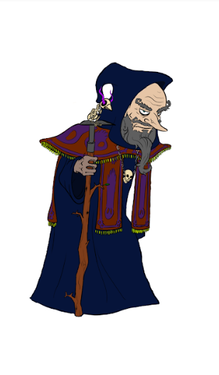

***The Elder***

The Elder looking over you, and possibly several other young necromancers. The Mentor answers to him, and the Elder is skilled in both old and new necromancy. Due to his appearance, he doesn’t go out to outside towns or cities and stays hidden when outsiders come close to the Necromancers. He’s fond of puns and often makes them when he wants to.

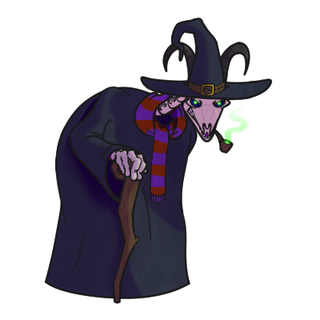

***The Merchant***

A grub who has traveled the world. While he’s traveled, he’s picked up many trinkets and items of interest. After gaining the confidence of the Elder Necromancers, he’s gained the right to sell his items and products to the residents. While his prices are high, you can get the items you need faster from the merchant than finding exactly what you want several times in the minigames.

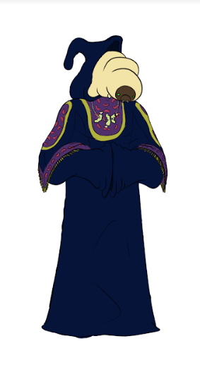

***The Graveyard***

A graveyard is a traditional place of necromancy at work. Many famous necromancers either got materials or worked exclusively in graveyards. However, this graveyard is the property of the necromancer society and is a safe place to work.

***The Marketplace***

The marketplace is run by the Merchant, and the standard of currency for the marketplace is teeth. The merchant has never blatantly said what the teeth are used for, but he’ll sell them back to people if they want to sell him resources. The marketplace started off as a small shack in a mausoleum but grew when the merchant was accepted by the Necromancer Society. Now it’s a big source of resources for necromancers who don’t have time to collect their own resources, provided they have the teeth to buy things.

# ***Resource Locations and Backstories***

***The Morgue***: The morgue throws out the bodies of people who have no family to take them. Naturally, the necromancers love to use these, as they are cheap and “ethical”. The morgue and the necromancers do not have a good relationship, as the necromancers use the bodies for questionable acts.  
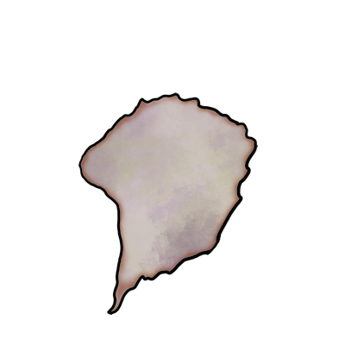

***Seance/Summoning*:** A pseudo-Seance is done by mediums often to provide comfort to those who’d like to say a last goodbye to those they loved but could not do so when they passed on. Necromancers do it as a way of drawing a departed soul forth and imprisoning them to use as a resource. Some Necromancers call this a Seance, others call it a Summoning. But Summoning the dead has roots going back to an ancient story, where a hero summons the dead to ask questions. This is similar, but binding the soul to an item which can be fed to an undead. The original practice of Seance originates from the Greeks and was meant to ask spirits questions.



***Rune Carving***: A necromancer carves magical runes into stones, then extracts the magic from them into a usable form. No magic goes into carving the runes, when runes reach a certain accuracy, generate limited magic.

***Monster Seeds***

While the process of raising monsters from the dead works rather well, it requires expensive materials to execute. If anything goes wrong during the process, the resources are lost. In the old days, necromancers had to look for corpses, and either had to work where the corpse was, or drag the corpse to their place of work. In dire situations, they even had to make a corpse.

Monster Seeds are mass-produced as a way of making undead or monstrous creatures quickly and cheaply. The Monster Seeds make the entire process faster and cheaper and were adopted relatively quickly.

## ***Flesh-Based Monsters***

### ***Zombie***

The simplest monster to raise from the dead. Because of this, it is the first monster a necromancer learns to raise. Most people outside of necromancy think that zombies are created using a virus. However, zombies are simply corpses imbued with necromantic power to do whatever the raiser wants. While in the soil, zombies are fed flesh-based resources to make them stronger. The necromantic process of raising a zombie makes the zombie rot, which made raising corpses quickly a necessity. The zombie seeds solved this problem. The seed is the essence of a zombie mixed with a starfish cactus, this helps make the zombie more deadly with serious diseases.

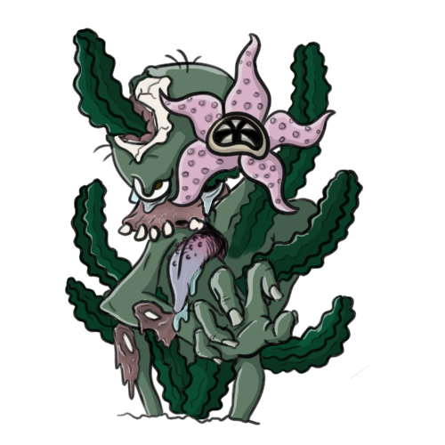

### 

### ***Wendigo***

Wendigo, while easy to raise, are dangerous to raise at the same time. Wendigo mostly desire flesh, but will happily crunch down bone and drink up any blood available. The Wendigo the necromancers use are formed from strong feelings of greed, a Strangler Fig is grown first around a suitable host plan before the Wendigo itself is grown to form a cage, until let loose by a necromancer. When they’re let loose, they’ll devour all before them, crunching, slashing, and drinking everything until they are killed or trapped by their necromancer masters.

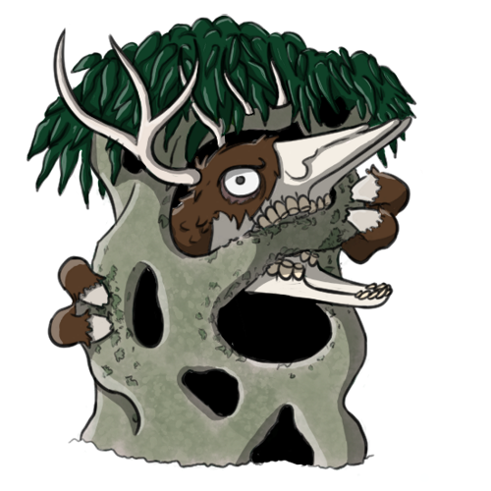

## ***Soul-Based Monsters***

### ***Jiang-Shi***

Vampires that suck the life force of the living instead of blood. They are monsters that are often created rather soon in a necromancers training, as they are an easy soul-based monster to create. These monsters originated from a virus in China that spread across the world. Talismans were made to control the Jiang-Shi, which allowed complete control over the monster. Nowadays, the virus has been contained, so Jiang-Shi needs to be created. Their seed is made with a much smaller talisman placed inside the vessel. This way, the Jiang-Shi will be under control immediately. Since they normally suck the life force of the living, the Jiang-Shi needs souls to grow within the soil.

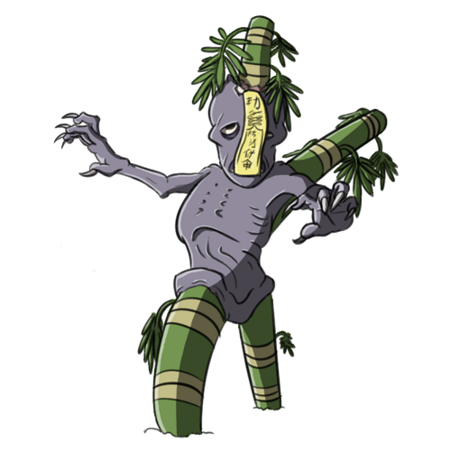

## 

## 

## ***Magic-Based Monsters***

### ***Mummy***

A mummy is a desiccated corpse of a living creature. The corpse eventually becomes so dry that the soul leaves the body, leaving nothing but an empty husk. This husk can be animated with magic to follow the creator, essentially creating an artificial soul. Since the soul has already left the body, little can go wrong with the animation process. This leads to a mummy being one of the first magic-based monsters an apprentice will learn to grow. A special kind of Syntrichia caninervis was developed to help this monster grow. This kind of Syntrichia caninervis absorbs magic and moisture, helping stabilize the mummy.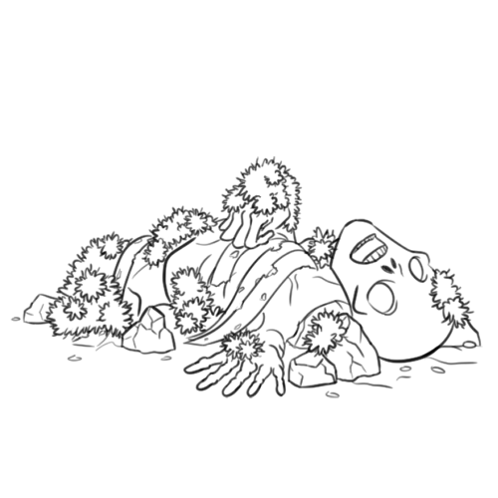

### ***Wraith***

A wraith is very similar to a ghost in the sense that they are a deceased spirit. However, they differ in the fact that their souls had trouble passing into the afterlife and have been drifting for some time. This caused the soul to become scared and, in some cases, vengeful. Wraiths, therefore, can be very dangerous if not handled correctly. Their seeds are Indian Pipe Flowers which give the Wraith a substitute to spiteful energy to grow. The flower is also planted in conditions that the wraith likes as well, which helps to keep it calm and strong. Given that they can be very dangerous, they are not commonly grown until a necromancer has trained for a while.

